**Use Case Description**

BY:HALEEMA SADIA

**UC: Register Project**

**Primary Actor:**

* Supervisor

**Pre-conditions:**

* The supervisor must be logged into the system.
* The project registration period must be open.

**Post-conditions:**

* The project is registered in the system.
* The project is now available for student selection.

**Input:**

* Project Title
* Project Description
* Required Skills
* Supervisor Name

**Output:**

* Project stored in the database.
* Confirmation message displayed to the supervisor.

**Main Success Scenario:**

1. The supervisor logs into the system and navigates to the "Register Project" section.
2. The system displays the project registration form.
3. The supervisor enters project details (title, description, required skills).
4. The supervisor submits the project registration form.
5. The system validates the data and checks for duplicate project titles.
6. The system stores the project in the database.
7. The system confirms successful registration.

**Alternative Scenarios:**

**Missing Fields:**

* If the supervisor does not complete all required fields, the system prompts them to enter missing details.

**Duplicate Project Name:**

* If the project name already exists, the system asks the supervisor to provide a different name.

**System Failure:**

* If the system crashes, project details are saved as a draft for later submission.

**UC: Approve Project**

**Primary Actor:**

* Supervisor

**Pre-conditions:**

* The supervisor must be logged into the system.
* The project must be in "Pending Approval" status.

**Post-conditions:**

* The project is either approved, rejected, or marked for modifications.
* The student receives a notification of the decision.

**Input:**

* Project details
* Student justification
* Supervisor’s decision (Approve, Reject, Request Modifications)

**Output:**

* Updated project status
* Student receives approval/rejection notification

**Main Success Scenario:**

* The supervisor logs into the system and navigates to the "Pending Project Approvals" section.
* The system displays a list of students who have registered projects.
* The supervisor selects a project to review.
* The system displays the student’s details, selected project, and justification.
* The supervisor evaluates the student’s capability and project suitability.
* The supervisor selects one of the following options:

**Approve:** If the student is suitable for the project.

**Reject:** If the project is not suitable for the student.

**Request Modifications:** If the student needs to refine their justification.

* The system updates the project status accordingly.
* The system notifies the student of the supervisor’s decision.

**Alternative Scenarios:**

**Student Not Qualified:**

* If the student lacks the required skills, the supervisor rejects the request with feedback.

**Project Already Assigned:**

* If another student has already been approved for the same project, the supervisor must reassign the student.

**System Failure:** If the system crashes, the supervisor’s progress is saved.

**UC: Receive Feedback**

**Primary Actor:**

* Student

**Pre-Conditions:**

* The student is logged into the system.
* The student has already submitted work product for review.
* The supervisor has provided feedback on the submitted work.

**Post-Conditions:**

* The student views the feedback provided by the supervisor.
* The feedback is stored in the system for future reference.

**Input:**

* None

**Output:**

* Displayed feedback text or attached review file.

**Main Success Scenario:**

1. The student logs into the system.
2. The student navigates to the "Feedback"section.
3. The system retrieves the feedback stored for the student.
4. The system displays the feedback provided by the supervisor
5. The student reviews the feedback and can use it for project improvements.

**Alternative Scenario:**

**No Feedback Available**

* If the supervisor has not provided feedback, then system displays: *“*Please check back later.*”*

**System Failure While Loading Feedback**

* If the feedback fails to load, the student receives an error message: “An error occurred. Please try again later.”

**Sequence Diagram:**

By: Haleema Sadia

**UC: Register Project:**

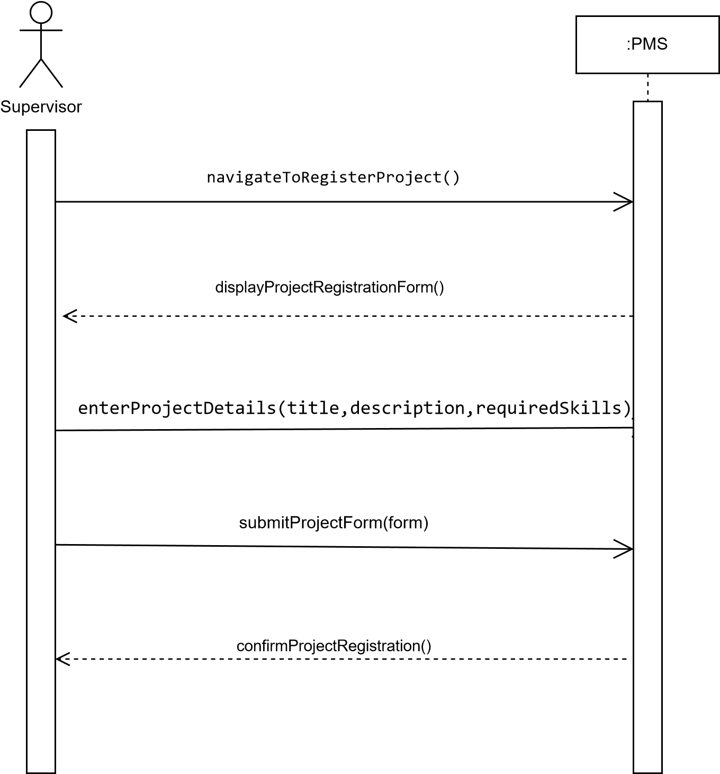

**UC: Approve Project**

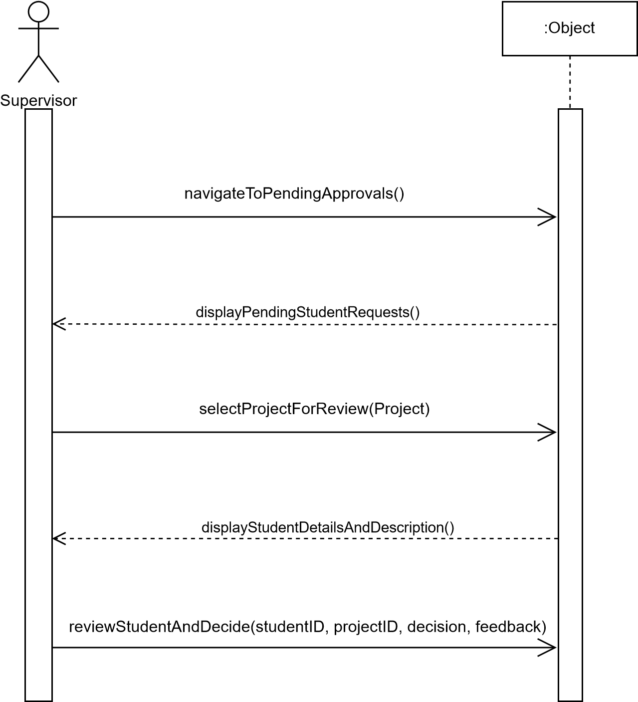

**UC: Receive Feedback**

